GAME ON GLOBAL



# GAME ON GLOBAL

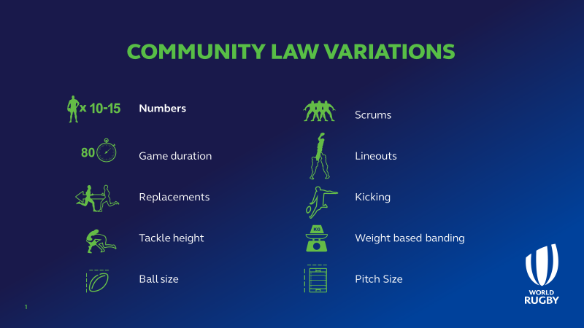

#### Number of players

Teams must be equal but can play with 10, 11, 12, 13, 14 or 15-a-side. Teams should agree on the team size prior to the game. In the event of no agreement, the decision defers to the team with the smallest number of available players. Teams who reduce numbers are allowed to maintain replacements. For example, a team with 13 players are able to play 10-a-side and utilise 3 replacements. Whichever number is settled upon, the game should be played under the 15-a-side laws of the game.

#### Game Duration

Games should be a minimum of 40 minutes, but can be split into equal halves, quarters or thirds e.g Teams could agree on a 60 minute match which could be 2 x 30 minutes, 3 x 20 minutes or 4 x 15 minutes.

If no agreement can be reached, revert to match lengths commensurate with team size:

• 10-a-side: 40 minutes maximum

• 11-a-side: 50 minutes maximum

• 12/ 13 -a-side: 60 minutes maximum

• 14-a-side: 70 minutes maximum

• 15-a-side: 80 minutes maximum

#### Replacements

Teams can utilize “Rolling subs” whereby players are able to return to the field of play as long as they are not injured. Competitions and teams can also apply the Half Game rule whereby all players must play at least half a match.

#### Scrums

As a start teams can reduce the numbers in a contested scrum. As a minimum this should mean:

• 10/11-a-side: 5 players

• 12/ 13 -a-side: 6 players

• 14-a-side: 7 players

• 15-a-side: 8 players as normal

• Teams/ competitions can also play with just 3 qualified front rowers in the team

Teams could also apply the U19 variation whereby scrums can only be pushed 1.5 metres or teams may agree that scrums will be uncontested. When scrums are uncontested there is no pushing, but the strike can be contested. It is recommended that scrum halves must pass from the base of the scrum.

For Game On it is recommended that there are no scrum resets and if a scrum is not successful, the game restarts with a Free Kick to the team who originally put the ball in.

#### Lineouts

Teams may agree not to contest or lift in the lineout. When uncontested the ball must be passed to the Scrum half.

#### Kicking

Teams/ competitions can consider interventions such as:

• Penalties & Free Kicks can only be kicked to touch from inside a team’s half

• All conversions are from in front of the posts

• Kicks in the attacking 22m cannot be marked

#### Pitch Size

It is recognized that pitches can be scarce or in poor condition in the community game. Some innovative solutions could be:

• Innovative use of current law 1 i.e., Permitted surface types being grass, sand, clay, snow, or artificial turf.

• 10-a-side on half a pitch, playing touchline to touchline with all conversions at the one set of posts

#### Ball Size

Teams and competitions to be permitted to use smaller balls in certain matches or competitions e.g. Size 4 or 4.5

#### Weight based banding

It is acknowledged that Rugby should remain a game “for all shapes and sizes” and diversity within a team makes it stronger. However, in some countries with higher levels of multiculturalism and challenges such as perceptions of risk and player transition from school to Senior rugby, then weight-based competitions may assist retention.

This game element maybe worthy of consideration where there are real differences in player size within a population. There are also potential opportunities in University/ College age groupings as a transition into adult rugby especially after a long lay-off e.g. COVID. Examples of weight based banding include NZR 70Kg tournament and at the other end of the scale the Fat boy 10’s in the Phillipines.

#### Tackle height

Unions and competitions may wish to consider adjusting the tackle-height from “the line of the shoulders” to the nipple line or waist-height. This has been successfully trialled in South Africa and France and when accompanied by coach and player support can lead to more offloads, more passes, more ball-in-play and a reduction in concussion. It may lead to less kicking and more tackles per match.

Some models of good practise from Unions in each of the specific areas will be collated and included at the Game on site, which will be ready prior to launch.

This effectively gives match Unions and match organizers three choices of tackle height: Shoulder (as per current law), nipple line or waist height.

# IMPLEMENTATION

From 1 January 2022 the Game On principles can be utilised by all World Rugby member Unions. The timing of implementation within a territory is at the discretion of the relevant Union. World Rugby also confirms that all age grade pathway laws and community laws are the responsibility of the National Governing Body/ Domestic Union. By officially recognizing Game On globally, World Rugby is supporting creative and flexible solutions to local participation problems whilst promoting the Community 15-a-side game.

Each Union will be responsible for instructing its member Clubs on logistical arrangements but typically it is the home teams’ responsibility to liaise with opponents and the Match Officials as early as possible. The global adoption of Game On also allows for cross-border matches and competitions to take place under an agreed framework of community laws. Each Union will also determine what levels and competitions can utilize Global Game On.